   QGI Spring Retreat – Farmstead Inn, Shipshewana, IN

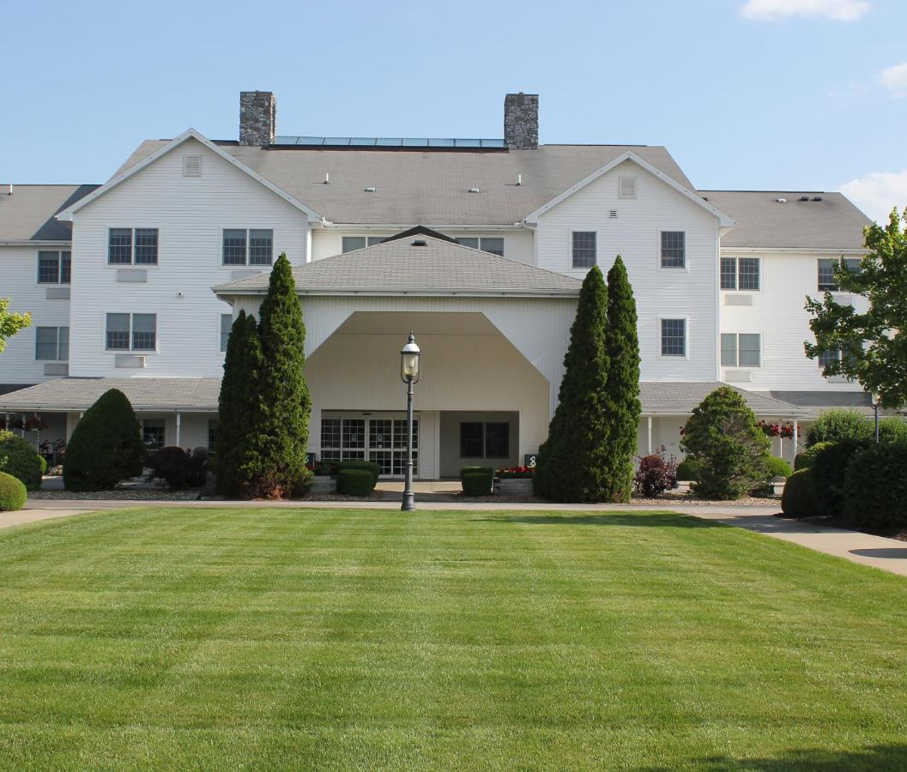

**Date:  Retreat Date is April 5th - 7th**

Registrants may mail their checks and registration requests to

Margie Lindeman

118 Yorkshire Blvd, E.

Cumberland, IN 46229

The cost is $350 per person for a single room (limited) or $250 per person for a double room.  Cost includes breakfast each morning.

Registration request should include:

Name: _______________________________________________

Email Address: _________________________________________

Phone Number: ________________________________________

Single Room ($350)  _______   Double Room ($250) __________

Roommate request:  ____________________________________

Reservations may be purchased on the website with a credit card at

[QGI Spring Retreat – Farmstead Inn, Shipshewana, IN | Quilters Guild Indy (quiltguildindy.net)](https://www.quiltguildindy.net/events-1/qgi-spring-retreat-farmstead-inn-shipshewana-in)

Single Room $360.45 ($10.45 convenience fee)

Double Room $257.55 ($7.55 convenience fee)

Registration closes March 1st, 2024.